Solid Principle

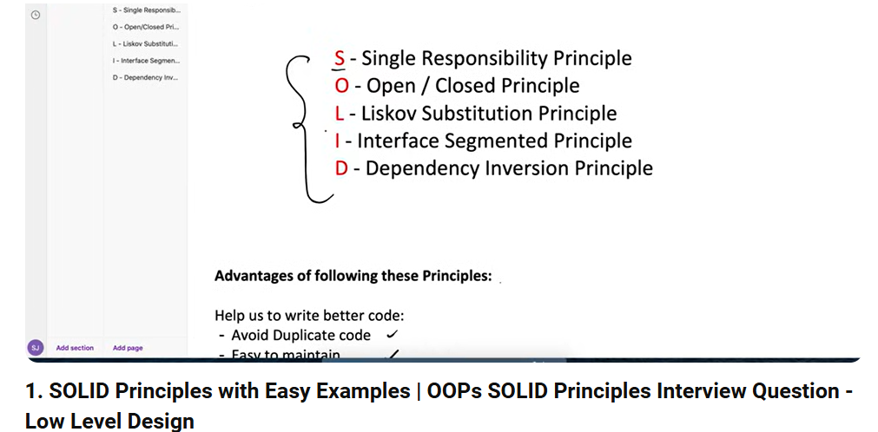  
  
  
Single Representational principal  
Open for extent close for modification  
Liskov substitution principal   
interface segment principal  
Dependency injection principal

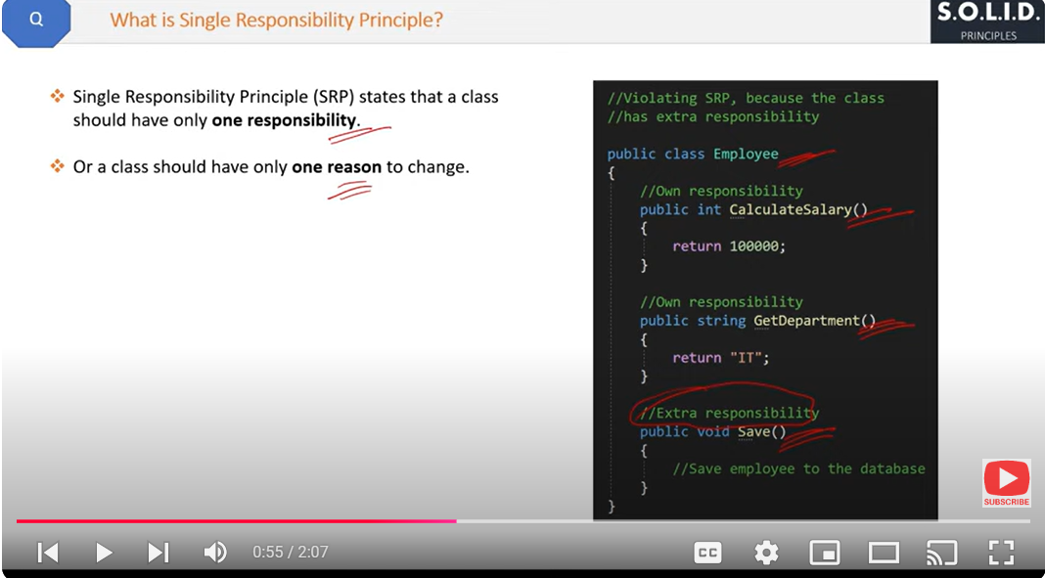

Separate Responsibility

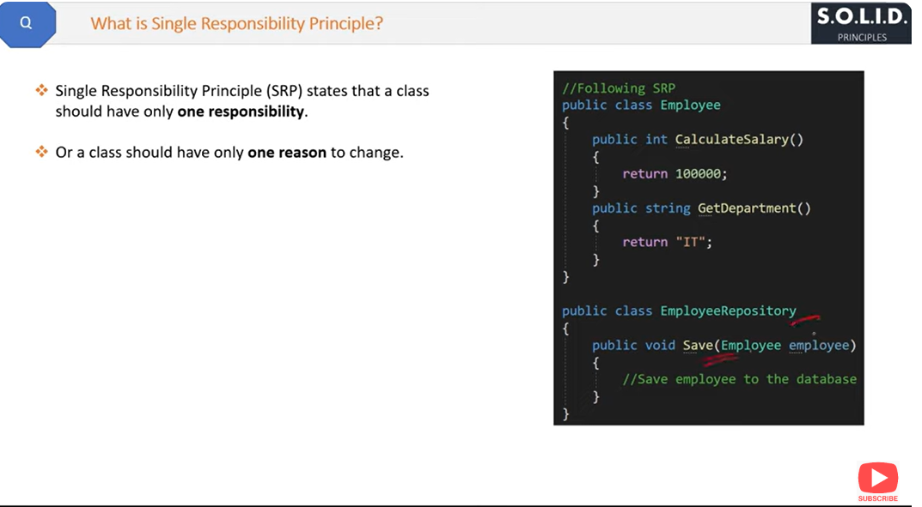

//////////////////////////////////////////////////////////////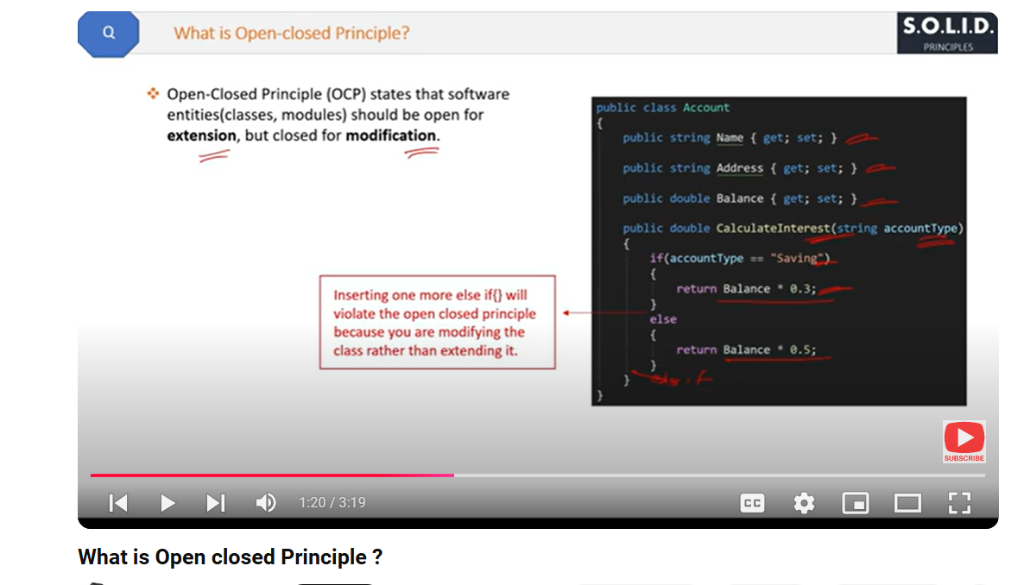

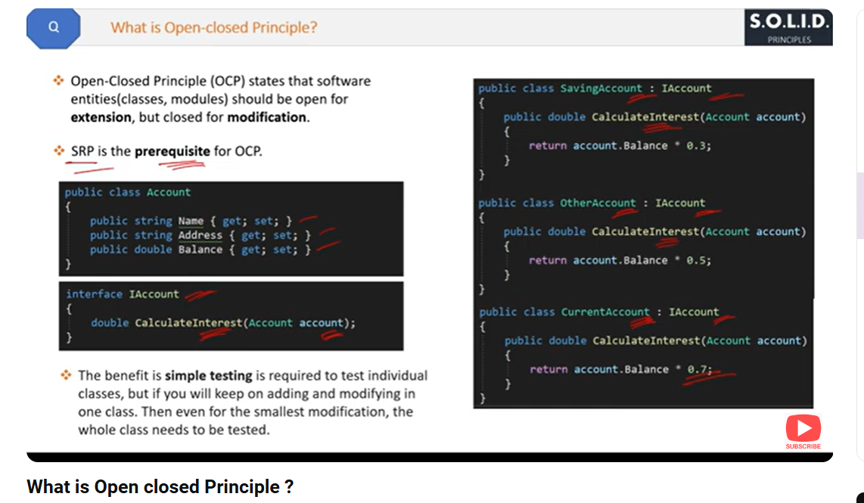

Child class

Sub class

Drive class are same  
///////////////////////////////////////////////  
parent class

Super class

Base class are same

/////////////////////////////////////////////////////////

LISKOV Substitution Principal

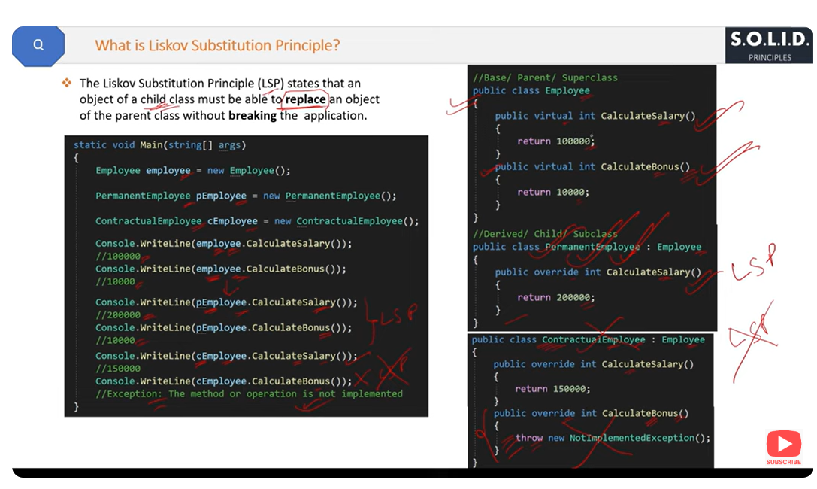

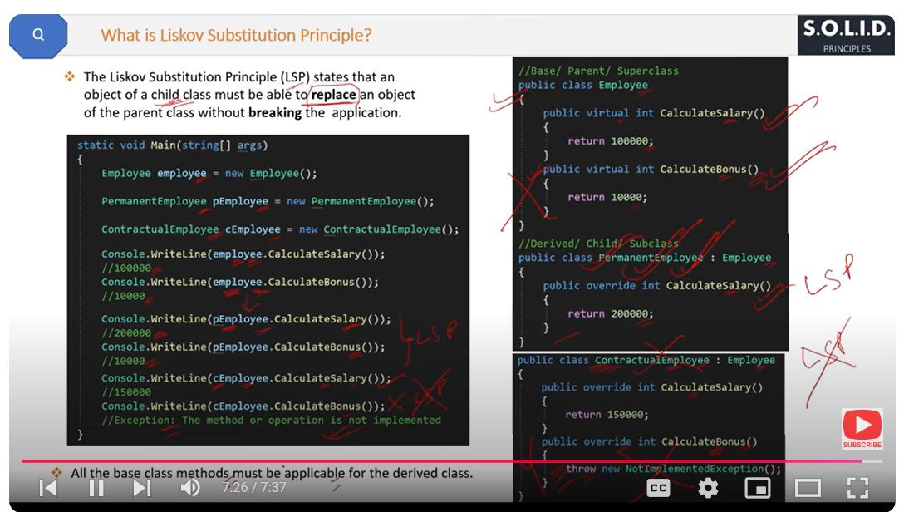

////////////////////////////////////////////////////////////////  
Interface SEGREGTION Principal

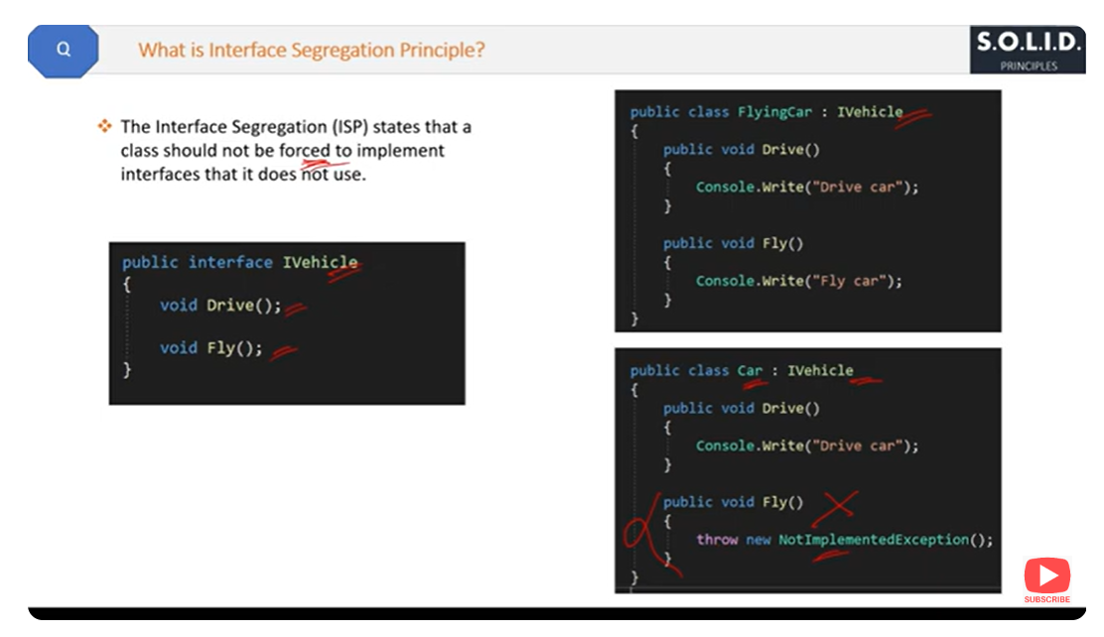

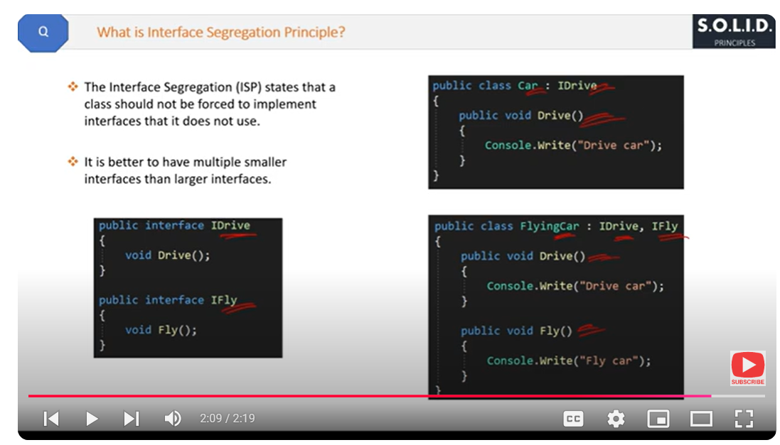

/////////////////////////////////////////////////////////////  
  
Dependency Inversion Principal

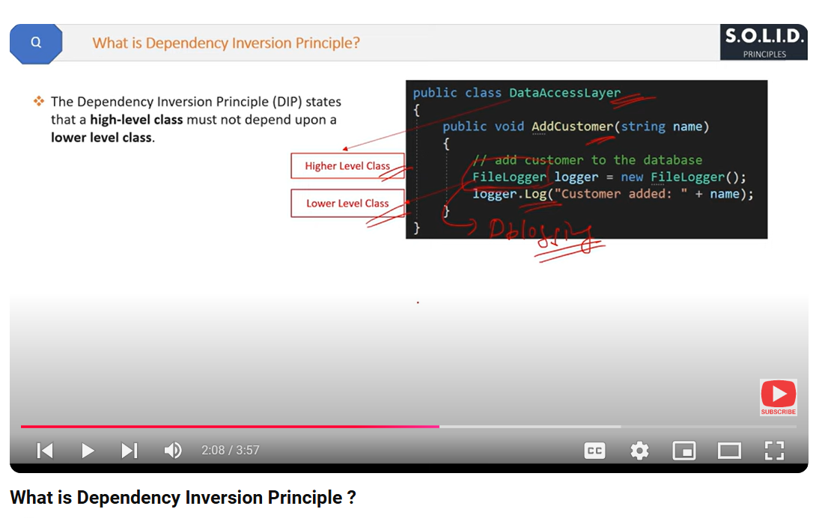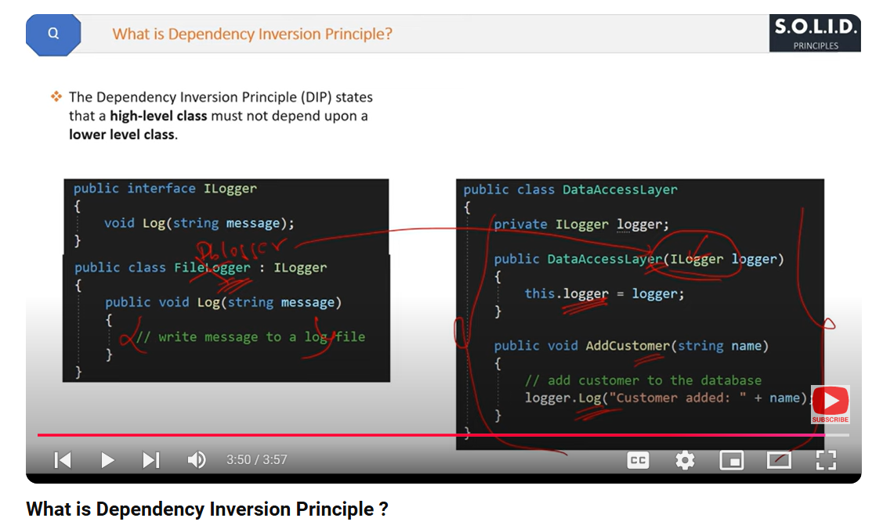

https://www.youtube.com/watch?v=8M7pLjacCPI&list=PL3aZbxdSiCbOO77O-zc7tGwviBM8-D5YY&index=5